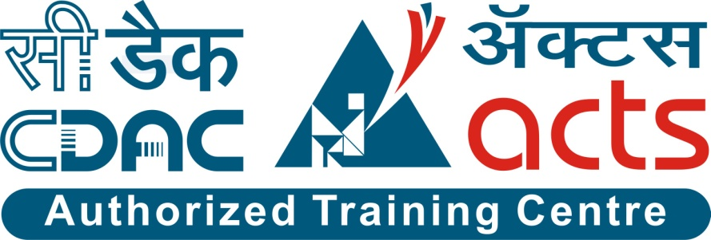

Project Name: TOUR PACKERS

Branch PG-DAC Sept- 2021.

Documentation On

**“TOUR PACKERS”**

PG-DAC Sept 2021

**Guided By: Monika Shivankar**

Submitted By :

**Group No: 24**

* **Shubham Borude 210943020015**
* **Omkar Dubal 210943020061**
* **Akanksha Sonawane 210943020097**
* **Tanvi Jahangirdar 210943020103**

**Table of Contents**

**1. Introduction 4**

1.1 Document Purpose **4**

1.2 Project Background **4**

1.3 Aim & Objectives **4**

**2. Business Requirements Overview**…………………………………………………………**5**

**3.Functional Requirements** **5**

3.1 Customer Module **5**

3.2 Admin Module **6**

**4.** **Non-Functional Requirement………………………………………………………………6**

**5. Use Case Diagram 7**

5.1 Admin **7**

5.2 Customer **8**

**6. Database Design 9**

1 Customer **9**

2 Tour **9**

3 Booking………………………………………………………………………………… **9**

4 Contact **10**

**7. E-R Diagram………………………………………………………………………………………11**

**8. Snapshots 12**

**9. Conclusion 20**

**List of Figures**

**Use Case Diagrams 7**

Fig 1 Admin 7

Fig 2 Customer 8

Fig 3 ER Diagram 11

1. **Introduction:**
   1. **Document Purpose:**

This document explains the system requirements and scope for developing Online Tourism System.

Tour Packers could divide the four main parts, Customer part, Tour Package part, Admin part and the Acknowledgement part.

## Project Background:

Tourism has changed quite a lot over the last few years. Maps on paper have shifted to Google Maps. Everything is designed to make our travels as hassle-free and as easy as possible. But travelling is more than just packing your backs and just going somewhere. Previously people were not able to do all the booking at one place. They needed to contact various agencies for various bookings. This project will come with some solution that going to solve lots of problems like a tourist can book his holiday packages before leaving the own house.

## Aim & Objectives:

* The purpose is to build a system that performs all operations related to traveling, booking, sightseeing, etc.
* This system connects customers and agents directly, provides a feedback mechanism for tourists maintains and controls the database of tourists’ information, and gives a variety of travel services.
* The purpose is to design a system using which one can perform all operations related to traveling and sight-seeing. The system allows one to easily access the relevant information.
* It is a dynamic and responsive system which let users to decide about places they want to visit and make bookings online for travel and accommodation.

1. **Business Requirements Overview:**

* Tour Packers is a Web application for various different tours booking for customer.
* Tour Packers is opened to the global.
* There are mainly two types of user. One is the Customer and other is Admin.
* Customer can select favorite tour package through Tour Packers, book the tour, do payment for booking tour etc.
* Admin can add, delete and update the packages and also check customer profile.
* Tour Packers is maintained by Admin.

# Functional Requirements Overview:

Tour Packers consists of two modules described as below.

1. Customer Module
2. Admin Module

# **3.1 Customer Module**

* Customer will get Login credentials from Admin.
* The Customer can search their favorite tour place and tour packages.
* Customer is able to select desired package and add into the cart.
* Customer could find what are pricing of different packages.
* Tour Packers System provides the function which allows Customer to provide feedback about the package.

# **3.2 Admin Module**

* Tour Packers should provide all functionality to admin how to handle the System.
* Admin should able to manage all the package related information with following activities.
* Admin can see the Customer tour details and store the information about the customer tour detail.
* Admin can also control and see the payment activity.

1. **Non-Functional Requirement:**

* The website should use professional design, look and feel and color scheme.
* Users will have no limitations for accessing the application through Internet. The portal being an internet application, it is difficult specify exact number of visitor or users. Hence we will target the system to support between 5 and 10 million users on launch of phase 1.
* Being a public website, the site must follow general usability guidelines for menus, navigation, colors, links and other actions provided on the screens.
* The system should be designed in such a manner that user will be able to complete tasks in minimum number of steps.

.

## 5. Use-Case Diagram

**5.1 Admin:**

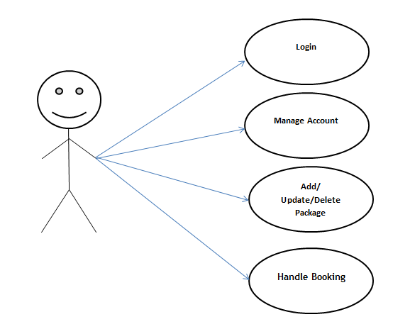

Fig. Use-Case Diagram for Admin

## 5.2 Customer:

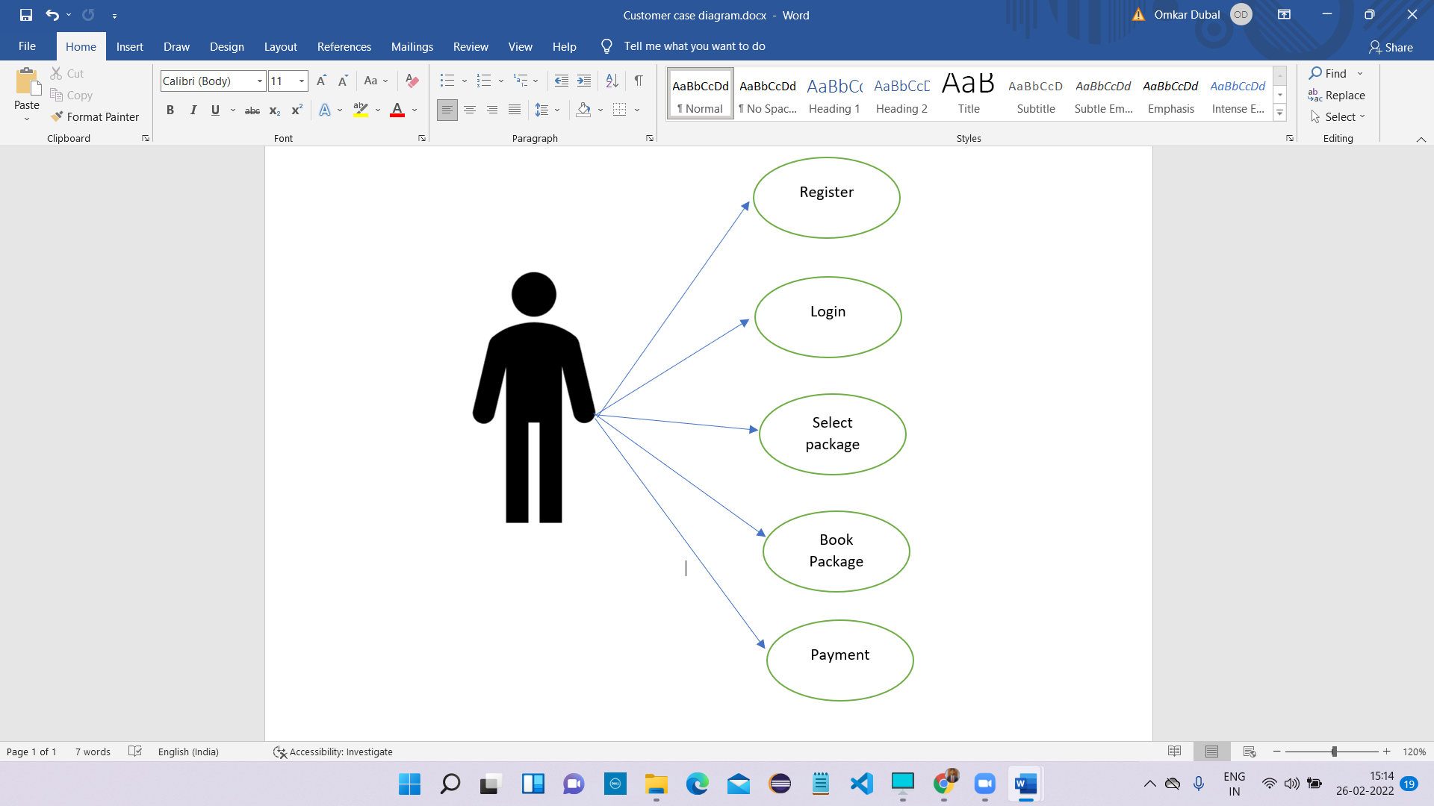

Fig. Use-Case Diagram for Customer

**6. Database Design:**

**1] Customer Table**

|  |  |  |  |  |  |
| --- | --- | --- | --- | --- | --- |
| **Field** | **Type** | **Null** | **Key** | **Default** | **Description** |
| cust_id | Integer | No | Primary key | AI | Customer ID |
| pwd | Varchar(45) | No |  |  | Password |
| fname | Varchar(45) | No |  |  | First Name |
| lname | Varchar(45) | No |  |  | Last Name |
| email | Varchar(45) | No |  |  | Email ID |
| Address | Varchar(45) | No |  |  | Address |
| city | Varchar(45) | No |  |  | Permanent Address |
| state | Varchar(45) | No |  |  | State |
| zip | DOUBLE | No |  |  | Area Zip |
| mobile | DOUBLE | No |  |  | Mobile/Contact |

**2] Tours Table**

|  |  |  |  |  |  |
| --- | --- | --- | --- | --- | --- |
| **Field** | **Type** | **Null** | **Key** | **Default** | **Description** |
| t_id | Integer | No | Primary key | AI | Tour ID |
| t_name | Varchar(45) | No |  |  | Tour Name |
| description | Varchar(5000) | No |  |  | Tour description |
| distance | DOUBLE | No |  |  | Tour Distance |
| days | Integer | No |  |  | No of Days |
| total_seats | Integer | No |  |  | Total Number of Seats Available |
| price | DOUBLE | No |  |  | Package Price |
| t_date | DATE | No |  |  | Date of Tour |

**3] Booking Table**

|  |  |  |  |  |  |
| --- | --- | --- | --- | --- | --- |
| **Field** | **Type** | **Null** | **Key** | **Default** | **Description** |
| booking_id | Integer | No | Primary key | AI | Booking ID |
| cust_id | Integer | No | Foreign key |  | Customer ID |
| t_id | Integer | No | Foreign key |  | Tour ID |
| payment_status | Varchar(45) | No |  |  | Payment status |
| booking_status | Varchar(45) | No |  |  | Booking status |
| book_date | DATE | No |  |  | Date of Booking |
| booked_seats | Integer | No |  |  | Number of Seats booked by user |

**4] Contact table**

|  |  |  |  |  |  |
| --- | --- | --- | --- | --- | --- |
| **Field** | **Type** | **Null** | **Key** | **Default** | **Description** |
| cont_id | Integer | No | Primary key | AI | Contact ID |
| name | Varchar(45) | No |  |  | Person Name |
| email | Varchar(45) | No |  |  | Person Email |
| number | Double | No |  |  | Phone/Mobile |
| subject | Varchar(200) | No |  |  | Subject of Contact |
| message | Varchar(1000) | No |  |  | Message to Tour Packers |

## 7. ER-Diagram:

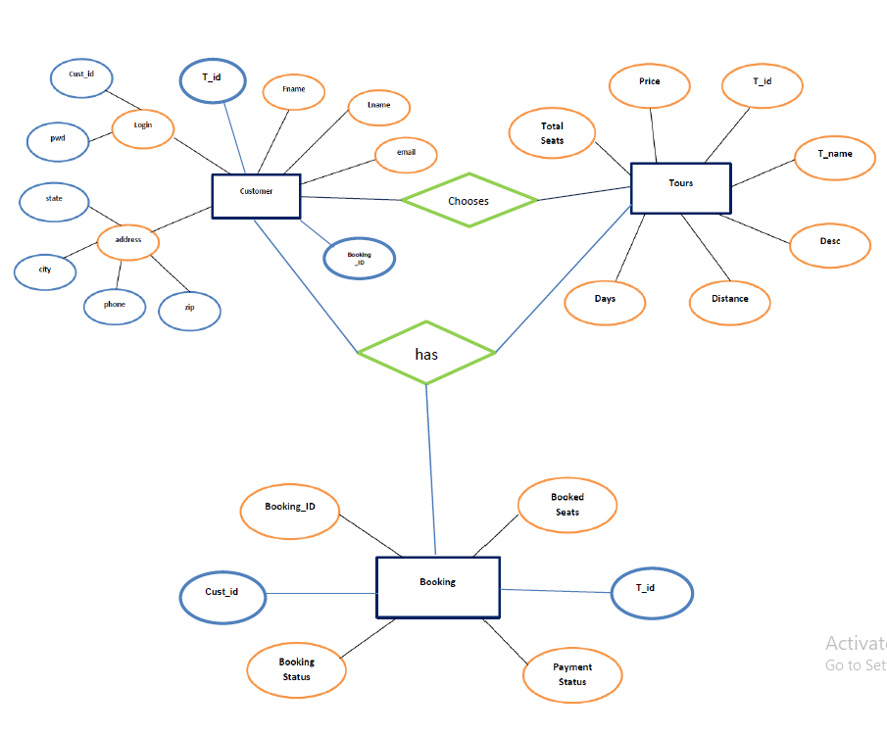

**E-R diagram shows database of Tour Packers System**

**8. Snapshots:**

**8.1 Home Page:**

Following snapshot shows the Home page for Tour Packers.

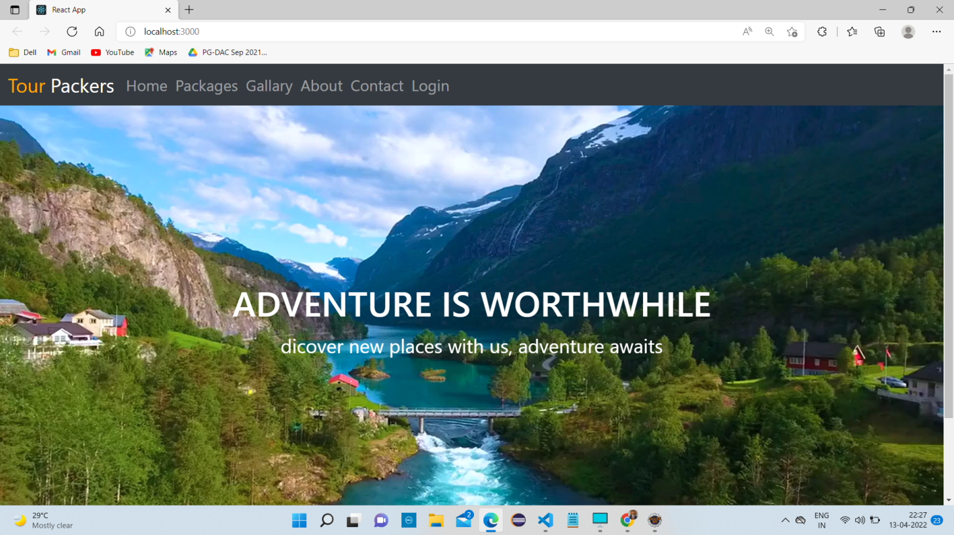

This page contains following controls

* Home
* Packages
* Gallery
* About
* Contact
* Login

**8.2 About Page**

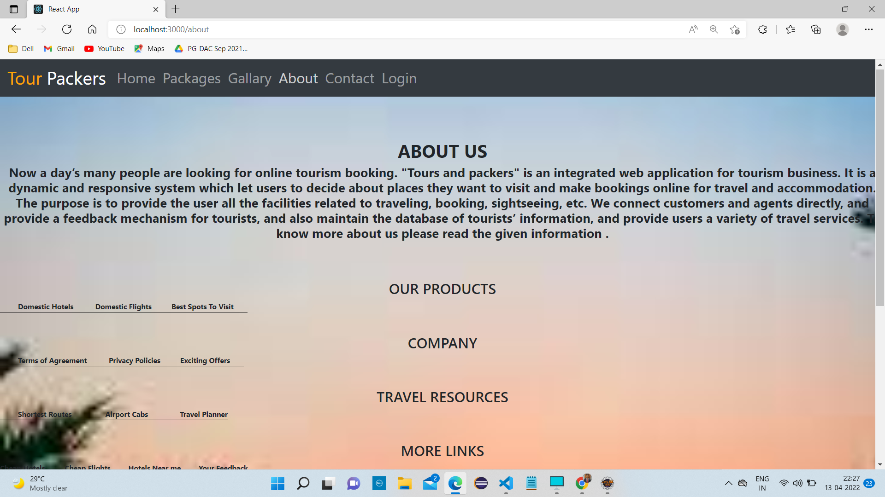

**8.3 Contact Page**

Following snapshot shows the Login page for Online Car And Bike Rental System

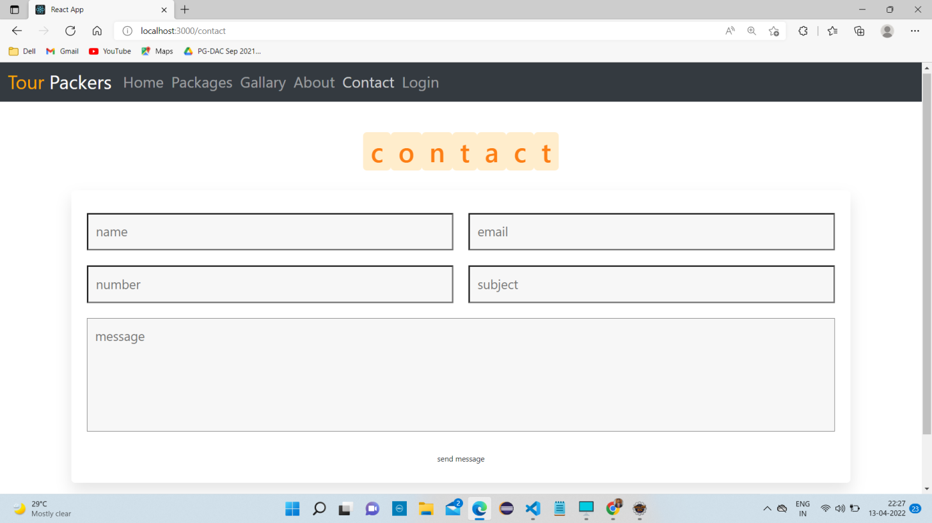

**8.4 Customer Registration Page**

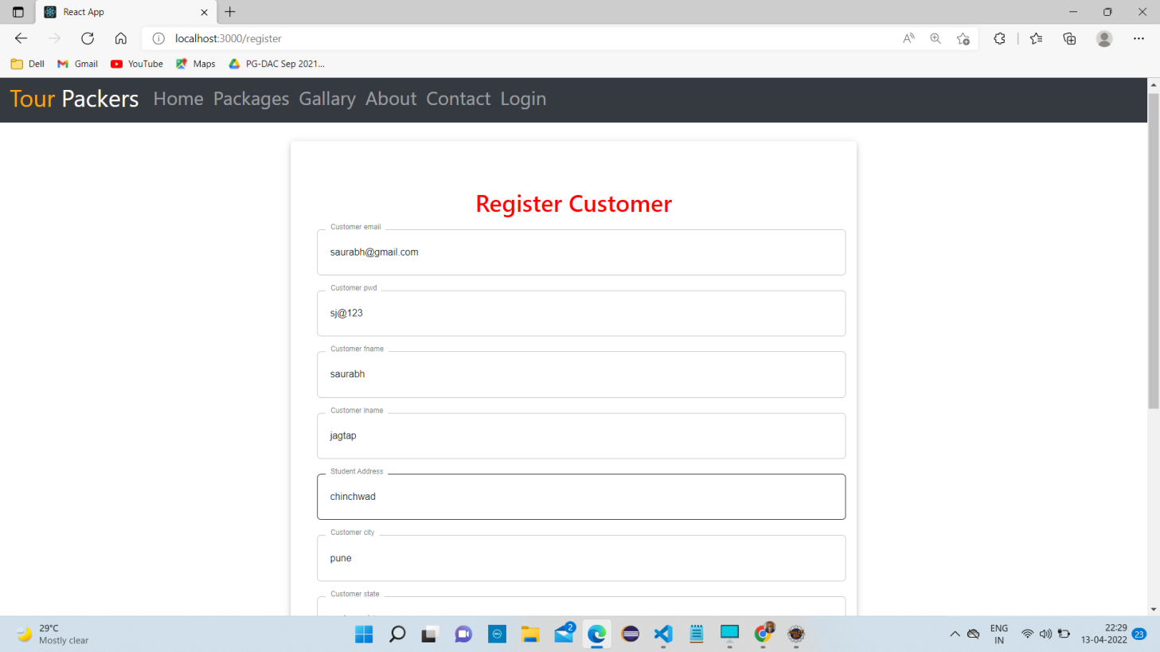

**8.5 Registration Success Page**

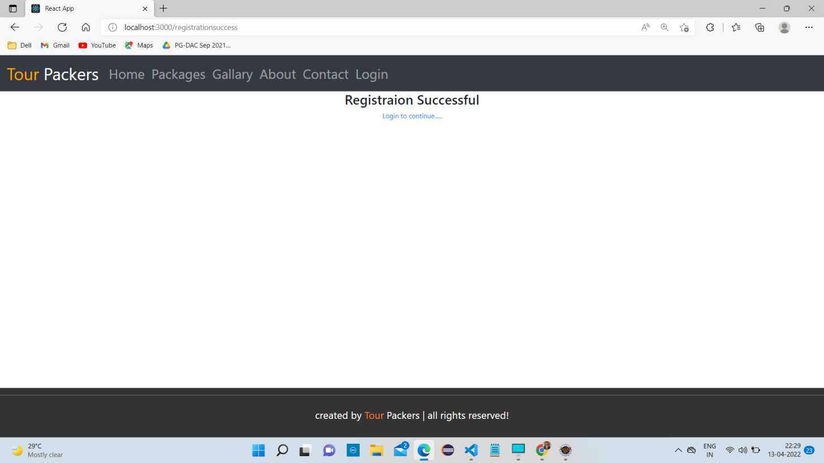

**8.6 Gallery**

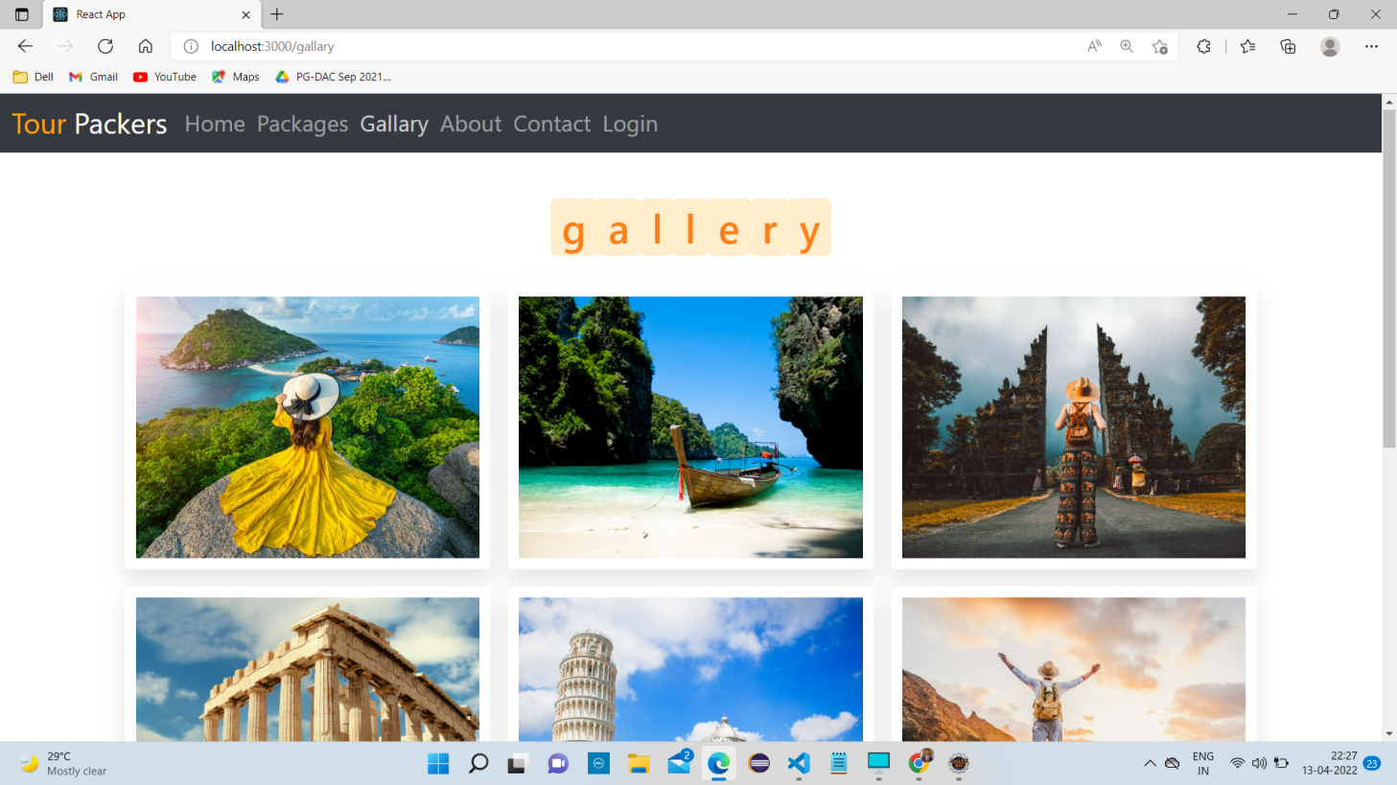

**8.7 Customer Page**

**8.7.1 Home Page**

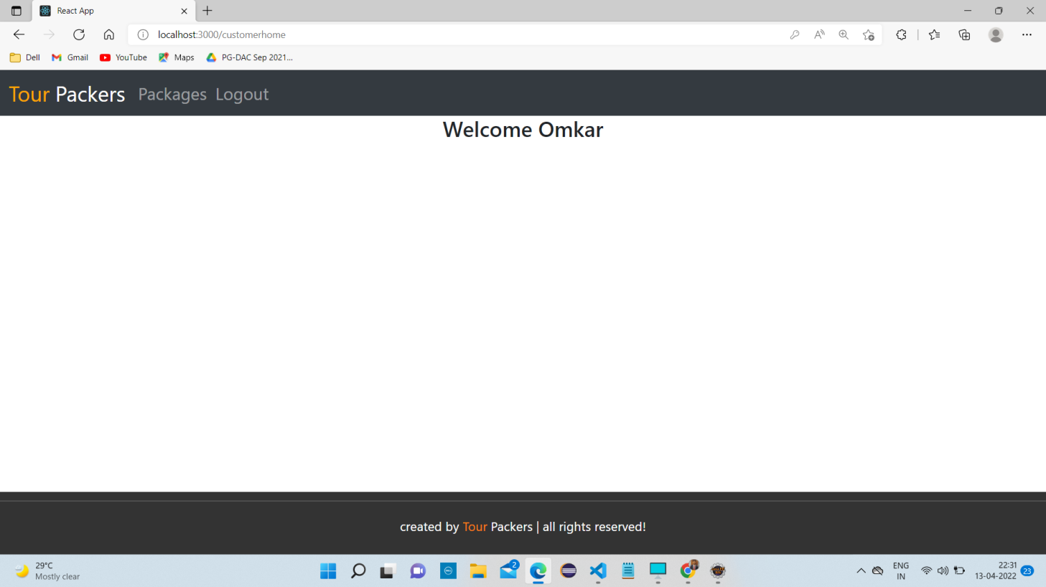

**8.7.2 Packages After Login**

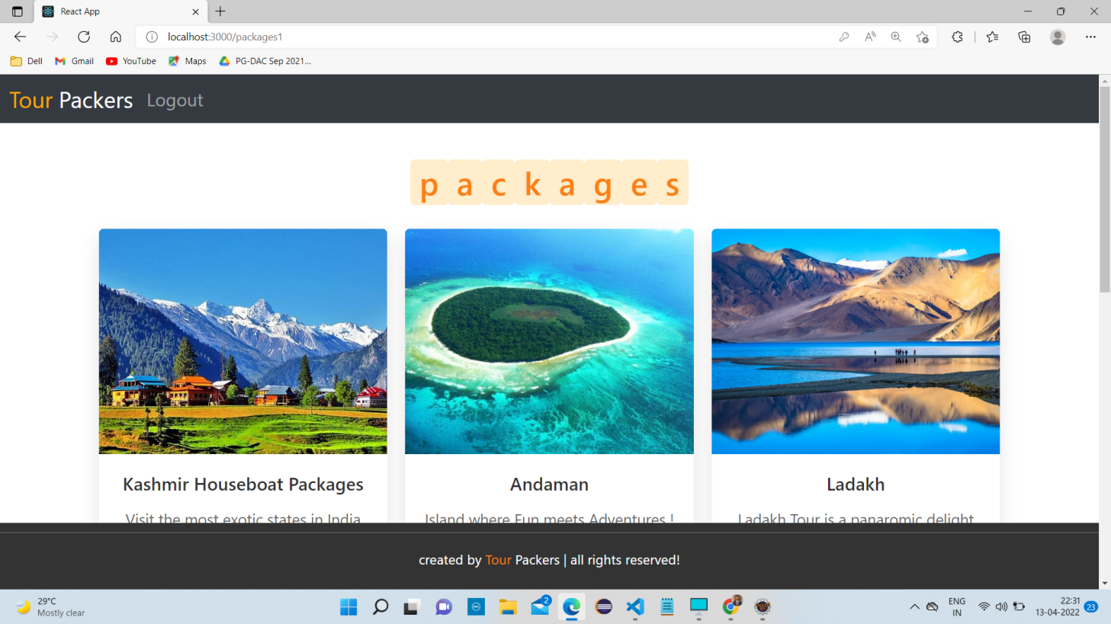

**8.7.3 Booking Page**

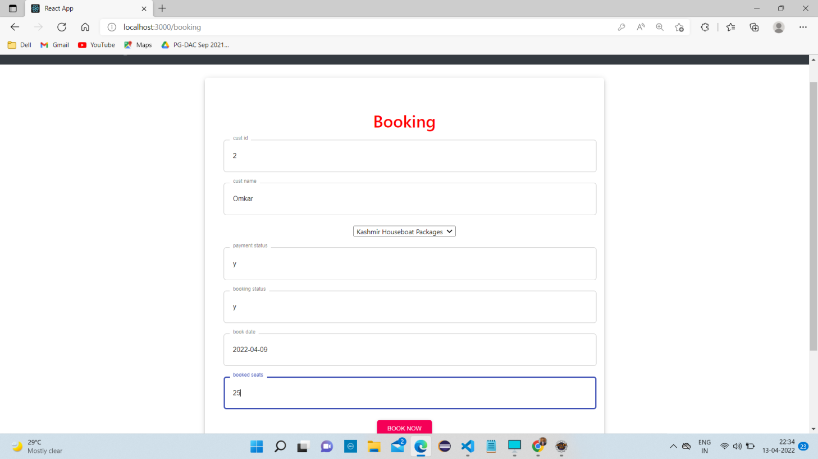

**8.7.4 Confirm Booking**

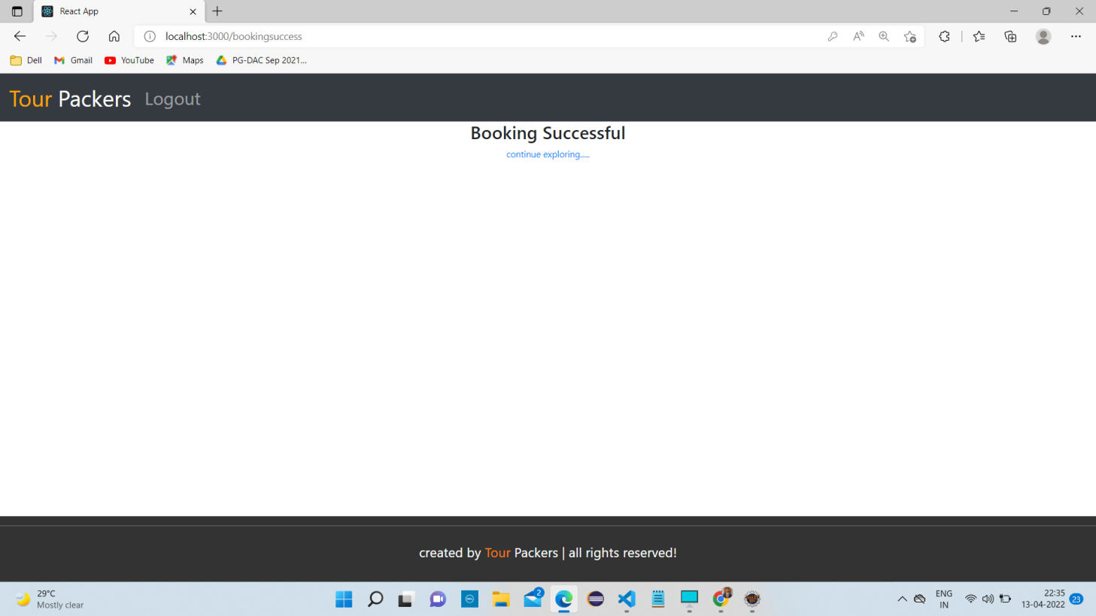

**8.8 Admin Page**

**8.8.1 Home Page**

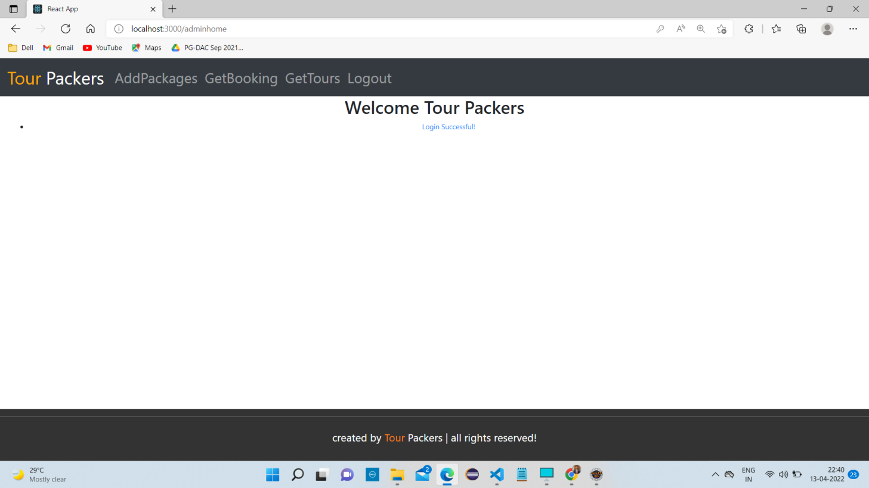

**8.8.2 Add Tour Page**

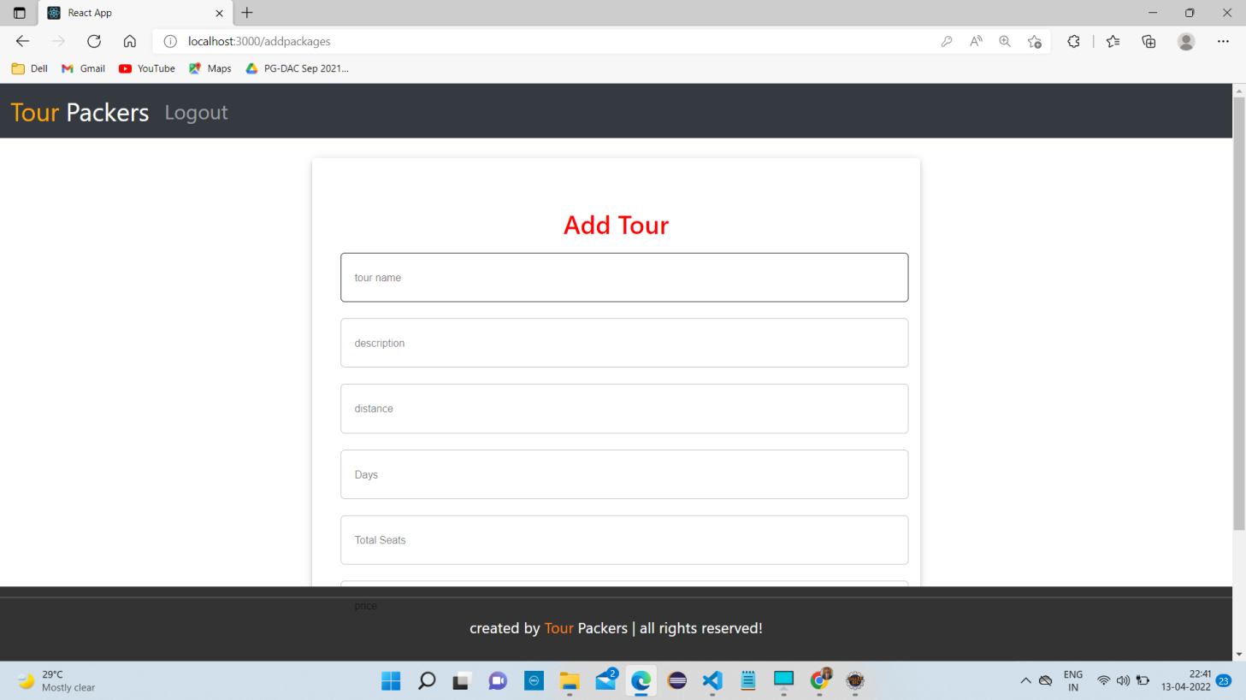

**8.8.3 Get Tour Details Page**

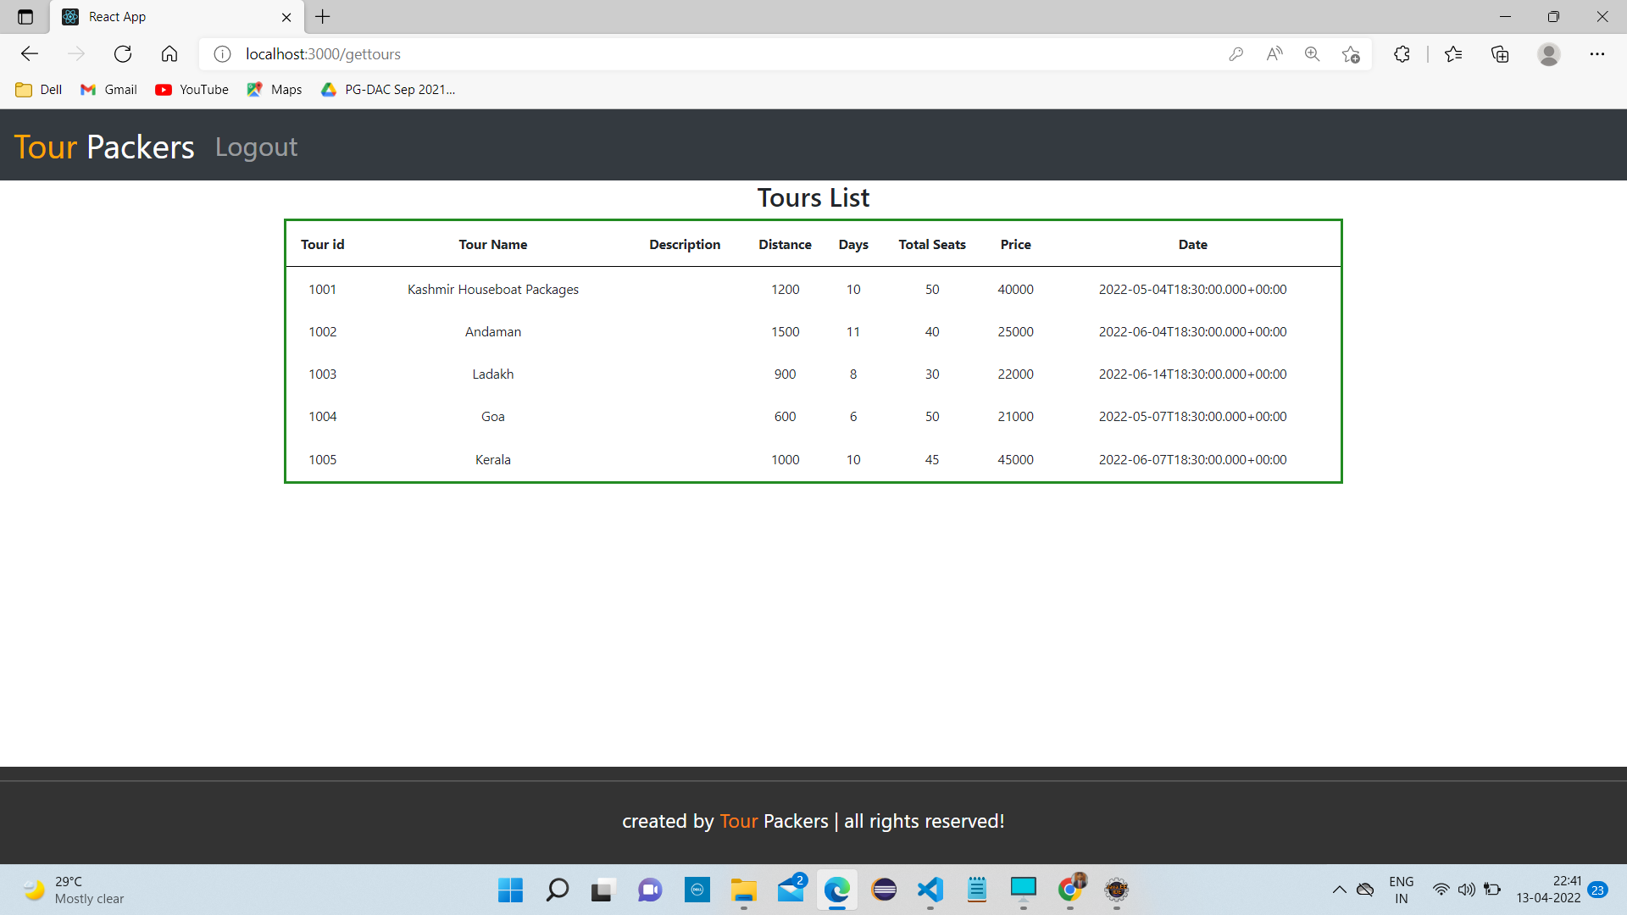

**8.8.4 Vehicle Details Page**

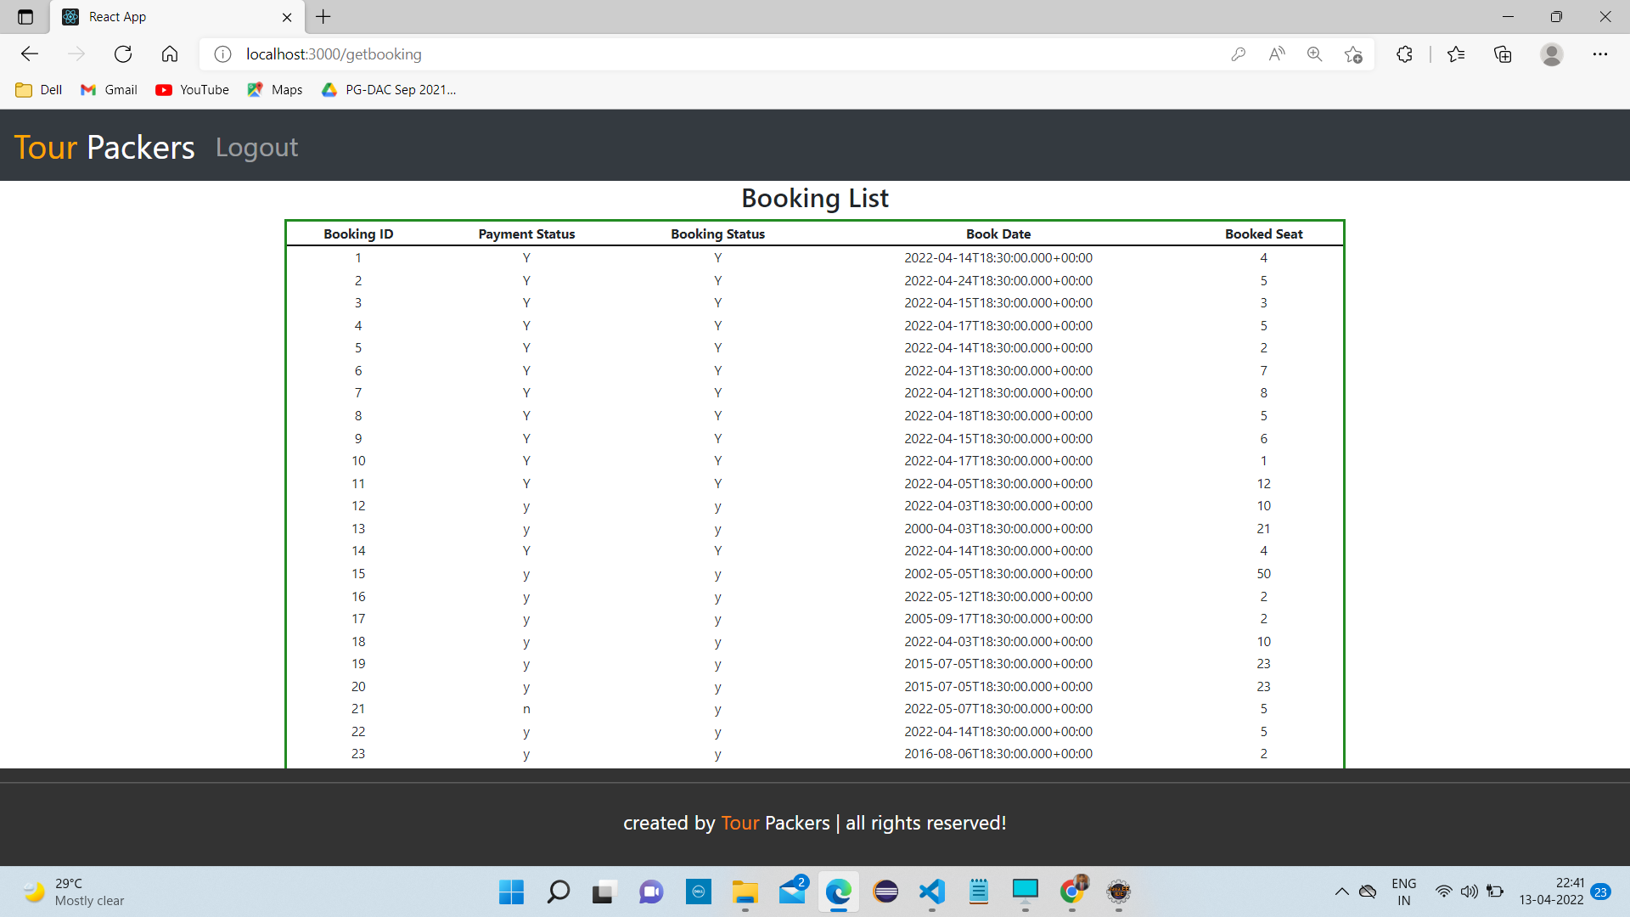

**9. CONCLUSION AND FUTURE SCOPE**

Tour Packers system is aimed efficient management of tourism management tasks like providing the desired packages for Customer on regular basis, managing payment for booking, adding the new tour packages. Admin can monitor daily Booking along with managing all the Customer Account and information on a single platform.

This web application was successfully created and stored all the tourism packages, booking data, creation of new tours packages along with tour details into the Tour Packer’s database. The application was tested very well and the errors were properly debugged. Unit testing also concluded that the performance of the system is satisfactory. All the necessary output is generated. This system thus provides an easy way to automate all the functionalities of consumption.

**FUTURE SCOPE:**

In the aspect of tourism, Internet and web technologies have made more readily available information on tourist locations, accommodations, transportation, shopping, food, festivals, and other attractions, thus improving the whole tourism experience. In the upcoming years we may add some features like Hotel Booking, Transportation, User Customized Packages, etc.